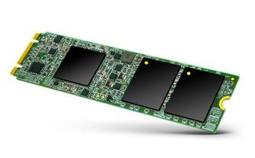

ADATA Premier Pro SP900 M.2 SATA (256GB)

The 256GB ADATA Premier Pro SP900 M.2 SATA is a compact solid-state drive (SSD) built into the M.2 SATA form factor. It uses the same circuitry as a 2.5-inch SSD version of the Premier Pro SP900; the main difference is that the newer drive is more compact, and made for upgrades on desktop or laptop systems that have the M.2 SATA interface on their motherboards. SSD prices have been dropping hard, but the price slashing is hitting gritty new lows due to moves by Samsung, one of the biggest flash-memory players. a Serial ATA (SATA) drive, is The 1TB version we tested will retail for an eye-poppingly when it goes on sale later this month, making it one of the least expensive internal SSDs that PCMag has tested at this—or any—capacity on a cost-per-gigabyte basis. For value-minded upgraders, it's a winner in our book, by almost every measure.

If you store all your data in the cloud, it might be hard to fathom an external hard drive doing double duty as a status symbol. That's exactly what the sleek, wildly fast, and eye-wateringly expensive Samsung Portable SSD X5 is, though. Following in the footsteps of both Samsung's own flagship external drives like the Portable SSD T5 and design-forward works of hard drive art from LaCie and others, the X5 offers copious amounts of solid-state storage at extreme speeds, thanks to its use of the cutting-edge Thunderbolt 3 and PCI Express NVMe interfaces. It would make a killer gift for Mac-bound video editors who shoot in 4K or photographers who work in RAW, but it's overkill for pretty much anyone else. If you store all your data in the cloud, it might be hard to fathom an external hard drive doing double duty as a status symbol. That's exactly what the sleek, wildly fast, and eye-wateringly expensive Samsung Portable SSD X5 is, though. Following in the PCI Express NVMe interfaces. It would make a killer gift for Mac-bound video editors who shoot in 4K or photographers who work in RAW, but it's overkill for pretty much anyone else.

SPEC DATA:

Type:
Internal

Storage Capacity (as Tested):
256 GB

Rotation Speed:
None

Ports:
SATA

